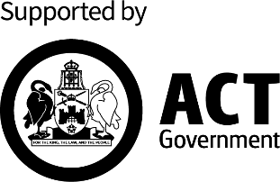
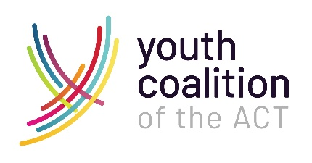

Expressions of Interest (EOI) Sought:

Learn how to deliver the “Talk to Them” training – responding to domestic and family violence (DFV) in youth work

The Youth Coalition of the ACT and the ACT Government - Domestic, Family and Sexual Violence Office (DFSVO) are seeking expressions of interest from individuals to learn how to deliver “Talk to Them” training to youth workers. As a trained facilitator, you will be delivering this two day training, which is coordinated through the Youth Coalition.

About the “Talk to Them” training
The ‘Talk to Them’ training aims to support youth workers with the knowledge and confidence needed to open a conversation with young people about DFV. Youth workers are trusted people that young people engage with for support. This training will increase the capability of youth workers to understand, recognise and respond to DFV issues, safely refer the young person and/or family to specialist DFV services, and continue to support them as they navigate the specialist DFV support system. This training was developed for youth workers, and is also delivered to other professions who work directly with young people.

At the completion of the “Talk to Them” training, participants should be able to understand:
- the dynamics of DFV
- how young people experience DFV
- how DFV impacts young people
- how to recognise DFV in the lives of young people
- the importance of responding to disclosures of DFV by young people in a trauma-informed manner that prioritises the safety of the young person and their family
- the need for ongoing open conversation with young people and their support network after a disclosure has been made
- the supports, services, and referral options available to workers supporting a young person with an experience of DFV.
We are seeking expressions of interest to facilitate this training from people with:
Essential
- At least 2 years’ experience of working with young people who have been subject to DFV
- Possess a valid ACT Working with Vulnerable People registration and a satisfactory National Police Check.
Desirable
- Demonstrated experience as a trainer or facilitator
- Relevant qualifications, capabilities, expertise or sector connections
- Demonstrated understanding of the dynamics of DFV and its impacts on children, young people and their families.

Commitment & Responsibilities
You will be required to attend the "Train the Trainer" sessions, which includes two days of training on November 6th and 7th. Additionally, you must complete the prerequisite reading beforehand.

If you haven’t attended and completed the "Talk to Them" training previously, you will need to attend a session in either September or October, prior to the ‘Train the trainer’ session.
You can register for the September training session at: https://events.humanitix.com/talktothemsep
You can register for the October training session at:
https://events.humanitix.com/talktothemoct
If a session is booked out, email thomas@youthcoalition.net

Upon successful completion of the training, you will be included in a pool of trainers who could be chosen to deliver the training over the next two years, based on availability and the specific demographics of each group.

You will be expected to discuss and seek approval of your organisation to allocate time away from your regular work to deliver the training. Your organisation will be appropriately compensated for the time you spend delivering the training. Alternatively, you can be personally remunerated if you are a sole trader.

Expression of Interest Process
- Interested individuals are encouraged to complete the attached brief EOI application form and provide a current resume.
- EOI applications are due by 20th September 2024.
- EOIs will be assessed by 4th October.
- Applications will be assessed by the Youth Coalition of the ACT and the ACT Government - Domestic, Family and Sexual Violence Office (DFSVO).
- Please send your completed form and resume to thomas@youthcoalition.net by 13th September 2024.
Expression of Interest Application Form

Learn how to deliver the “Talk to Them” training – responding to domestic and family violence (DFV) in youth work

Name:
Position:
Organisation:
Phone number:
Email address:

Have you attended and completed the “Talk to Them” training?

If not, have you registered to attend the September or October session?

Please provide a response to the following three questions within a maximum of two pages.

- Why are you interested in becoming a trainer to deliver the “Talk to Them” training?

- Please describe the relevant experience, capabilities, expertise and/or sector connections to the DFV and/or youth sector that you could bring to being a trainer.

- What is your understanding of the drivers and dynamics of DFV and its impacts on young people?

Please send your completed form and current resume to thomas@youthcoalition.net by 20th September 2024.

